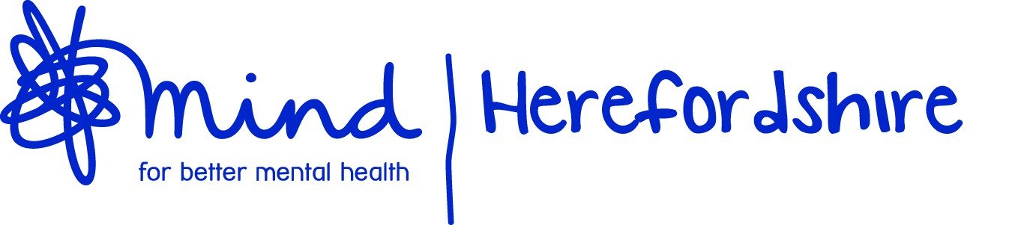

JOB DESCRIPTION

Job Title: Community Support Team - Support Worker

Responsible to: Housing & Community Team Manager

Date: May 2021

PURPOSE OF THE POST:

- To ensure that the highest standard of personalised care and support is provided to all service users.

- To ensure that all service users are seen as individuals and are always treated with dignity and respect, involving them in all discussions about care, treatment and support.

KEY RESPONSIBILITIES:

- To be flexible and responsive to the needs of service users as directed by their individual support plans.

- To advise and support service users in all aspects of managing their tenancy and maintaining the safety, hygiene and comfort of their homes.

- To promote the service user’s self-esteem and enable them to express their preferences and make choices and decisions.

- To enhance the confidence and coping abilities of service users through encouragement and positive feedback.

- To enable service users to develop skills in planning and self-organisation and to encourage them to maintain appointments and commitments.

- To advise, encourage and support service users so as to maximise their self-care and independent living skills.

- To support service users in budgeting and managing their finances and to ensure that they are able to maximise their income by liaising with Welfare Rights Agencies.

- To encourage service users to identify their strengths and interests and to support service users in accessing social, leisure, education and work activities.

- To encourage service users to take as much responsibility as possible for their own physical and mental health and to access primary health care and other services.

- To assist in monitoring service users mental health and general well-being and to inform the Service Manager of any concerns or significant changes in their needs and circumstances.

- To report any concerns regarding children or vulnerable adults with immediate effect to the Service Manager/On Call Manager.

- To support service users in managing self-medication programmes.

- To work within agreed risk management guidelines and to assist service users in reducing risks to themselves or others, promptly reporting all concerns regarding risks to Service Manager/On Call Manager.

- To maintain a high standard of customer care, encourage feedback from service users and other agencies and promptly report and document all complaints, suggestions and feedback.

- To maintain a warm and responsive approach to families and to report their feedback and concerns.

- To take appropriate action in the event of emergencies, ensuring that the Service Manager/On Call Manager is informed promptly.

- To document and communicate effectively any relevant information that relates to all service users and ensure that accurate records are kept in the prescribed format.

- To document all work undertaken in support of service users, their general progress, any concerns and any communication or liaison with other agencies.

- To notify your Line Manager of planned whereabouts and to submit accurate timesheets regularly.

- To provide regular verbal reports to your Line Manager.

The following are standard organisational responsibilities:

- To accept regular support and supervision from your Line Manager.

- To carry out all work in a manner consistent with the aims of the service principles adopted by Herefordshire Mind.

- To ensure that you are familiar with and comply with all organisational policies, procedures and legislative requirements governing the organisation.

- To work in accordance with health and safety legislation ensuring you are aware of your personal responsibility for health and safety.

- To be committed to improvements, innovation and advances in supporting practices and approaches in mental health.

- To work within confidentiality applying the principles of data protection and record-keeping and data-sharing, and compliance with the Data Protection Act.

- To promote the organisation and its values and beliefs at all times to maintain its good reputation.

- To attend and complete all mandatory training, adopting up to date and relevant knowledge within the working practice.

- To take responsibility for your own personal and professional development.

- To offer suggestions, advice and comments towards continuous improvement in a structured and constructive way.

- To carry out any other duties commensurate with the role, as required.

PERSON SPECIFICATION

 | ESSENTIAL | DESIRABLE | METHOD OF ASSESSMENT
EXPERIENCE | - Awareness of mental health Issues  - Previous experience of working in a mental health supportive environment or other care setting. | - Experience in dealing with individuals with challenging behaviour. | Application Form  Interview
QUALIFICATIONS | - Good standard of general education.  - Willing to undertake further training in line with service requirements. | - NVQ Level 2 Health & Social Care or equivalent  - Mental Health qualification | Application Form  Interview  Evidence of Qualifications
SKILLS | - Good communication skills, with an ability to speak and understand English  - An empathetic approach  - Team player  - Self-motivator  - Ability to use initiative and work independently  - Good organisational skills  - Willingness to learn  - Caring and non-judgemental  - Good IT skills, knowledge of Microsoft Windows  - Displays discretion and the ability to maintain confidentiality at all times. |  | Application Form  Interview
OTHER | - Flexible approach to working hours  - Committed to equal opportunities, anti-discriminatory and anti-oppressive practice.  - Full UK driving licence |  | Application Form  Interview

Signed: Dated:

